**RSE2107A - Implementing and Proving a Solution**

Introduction

* This document outlines the implementation and evaluation of the LIMO Bot autonomous navigation system. It describes how the system was realized through the integration of the physical arena, robot hardware and software components, and explains the verification and validation activities conducted to ensure it meets the defined technical requirements and project objectives.

System Realization

* We transitioned from concept to realization by combining physical, software, and operational components into one working system.
* Physical Arena Realization
  + We designed and constructed the arena based on the Changi Airport Terminal 3 departure hall theme.
  + The arena base was built using foam sheets, with the LIMO Bot’s navigation path enhanced using rough sandpaper to simulate textured flooring.
  + The central structure, the terminal shell, replicates key architectural features, with PVC barriers added around the exterior to improve LiDAR detectability and ensure safe navigation boundaries.
  + Inside the terminal shell, we placed key attractions such as the daisy sculpture and green wall to enrich the environment both aesthetically and functionally, offering realistic navigational challenges.
  + Throughout the construction process, we carefully balanced weight, durability, sensor compatibility, and aesthetic quality, maximizing the use of our allocated budget to deliver a robust and realistic arena setup.
* Robot Realization
  + The Agilex LIMO Bot was configured with a tracked wheel setup to enhance traction across the arena’s varied surfaces.
  + While hardware modifications were restricted by project constraints, we relied on the robot’s built-in sensor suite — including LiDAR, IMU, and wheel encoders — to provide the critical input data needed for the navigation stack.
  + We acknowledged trade-offs such as increased odometry drift and mechanical stress, and planned software-level adjustments to mitigate these risks.
* ROS1 Navigation Stack Realization
  + RTAB-SLAM for real-time loop-closure mapping.
  + AMCL for continuous localization.
  + Dijkstra algorithm for global path planning.
  + DWA as local planners to avoid obstacles and handle real-time path adjustments.
  + Configured recovery behaviors: reverse/replan, rotate/scan.
  + Visualization and simulation using RViz and Gazebo.

Verification table

| Component | Verification Criteria | Verification Method | Tools Used |
| --- | --- | --- | --- |
| Arena Structure | Dimensions match CAD/model specs; materials securely assembled | Inspection & Measurement | Solidworks,Visual Checklist |
| SLAM System (RTAB) | Map quality, loop closure under expected noise and drift conditions | Simulation-based testing | RViz (Robot Visualisation), ROS Bags, Gazebo |
| Localization (RTAB) | Accurate pose estimation from graph optimization; stable loop closures; drift correction over time | Simulation-based testing; observation of pose consistency under motion and loop closure events | RViz (graph + pose visualization), RTAB-Map GUI, ROS Bags |
| Pathfinding (Dijkstra) | Path completion under known map within expected time & optimal length | Static map path generation | Move_base logs, Costmap Analysis |
| Sensor Integration | LiDAR, IMU, and encoders provide synchronized & valid data | Data stream consistency and rate checks | rostopic echo (real time data),  rqt_graph (computation graph) |
| Software Stack (ROS1) | No broken dependencies, launch files execute as expected | Code review and unit testing | GitHub Continuous integration/Delivery ,  roslaunch test sets |
| Performance vs. Time Constraints -  (Within time limit) | Timed trials | trials completed within our estimated time limit | Success Rate within time Limit |

Validation Table

| Validation Domain | Method | Stakeholder Needs Addressed | Evidence of Success |
| --- | --- | --- | --- |
| Arena Aesthetics | Stakeholder walkthrough | Similarity to Changi Terminal 3 concept | Feedback Received by Professor |
| Map Accuracy | Human-observed vs. generated map comparison | Environment matches robot’s perception | Visual Alignment,  Map Error Tolerance met |
| End-to-End Navigation -  (Completion of Course ) | Physical Arena Trial | Accurate & continuous navigation through full route | Navigate the full route of the arena. |
| System Reliability -  (Does not break down ) | Consecutive trail runs | System must complete each trial with no crashes or loss of function | Acceptable Mean time between failures (MTBF,  Works Consistently without malfunction |

Our Implementation- LIMO bot

* Our team uses RViz to visualise the real-time mapping generated by the RTAB-Map process. RViz displays the resulting 2D occupancy grid, robot trajectory, and point cloud data as the LIMO bot navigates the environment. In the visual output, black cells represent detected obstacles, white areas indicate free space, and coloured lines show the planned and executed navigation paths. This setup allows us to monitor the system’s performance and verify that the selected configuration enables reliable and accurate autonomous navigation.

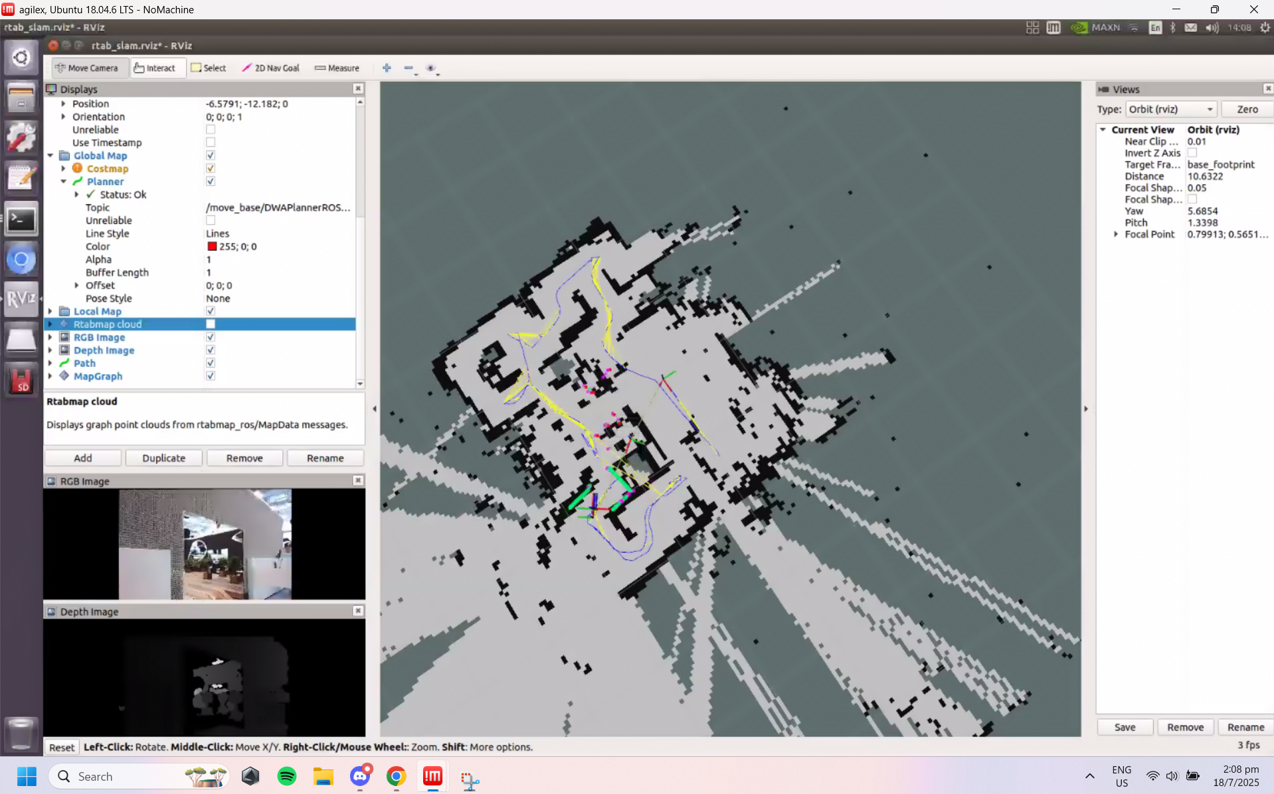

Our Implementation- Arena

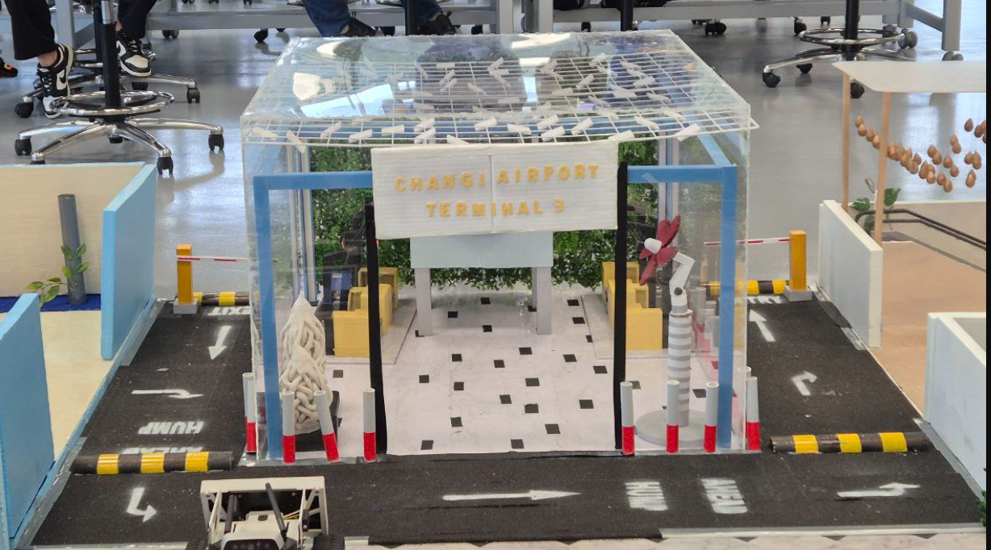

* This is our completed arena layout, accompanied by its elements and obstacles. The strategy in mind is to simulate a realistic segment of Terminal 3. Surrounding the center terminal shell is a designated path for navigation, slowly leading to the terminal entrance. Boundary barriers are placed strategically to prevent collisions from the central structure. Ends of the path are blocked by static gantry.
* As the LIMO bot progresses, it will enter the terminal shell structure, which represents the interior of Terminal 3. This transition allows the LIMO to experience both outdoor and indoor navigation. Our outdoor path includes minor obstacles such as small humps to simulate uneven terrain and to test motion stability. Then as it enters the terminal shell, there will be surrounding elements to act as dead ends to guide the path of the LIMO to trigger autonomous recovery behaviours of reversing.

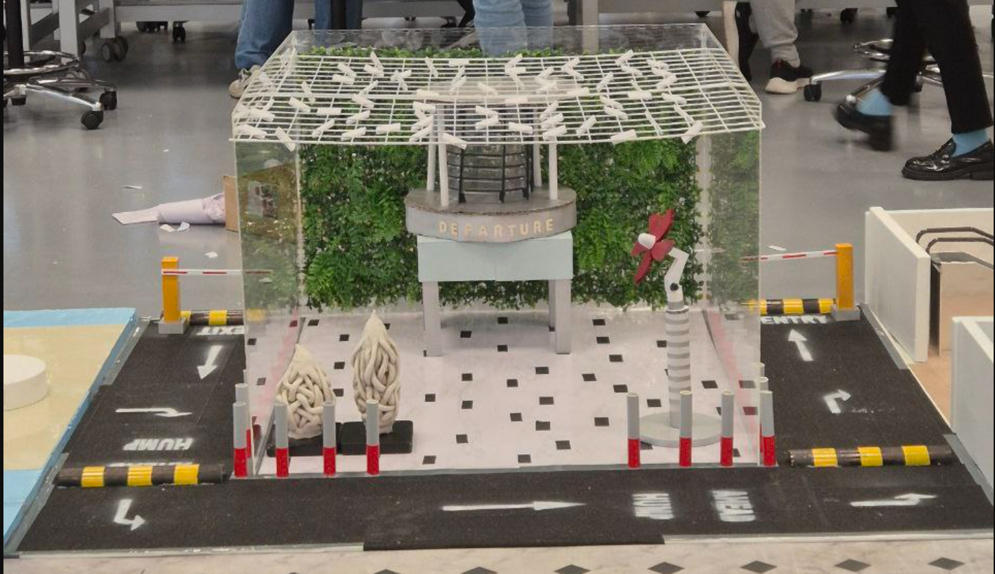  
Front View- Road, Terminal Shell, Boundary Barriers

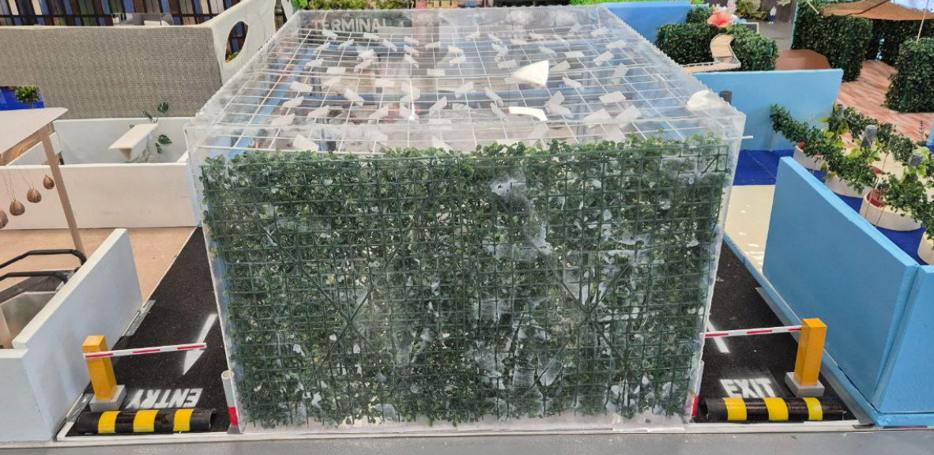  
Back View- Humps, Static Gantry, Garden Wall

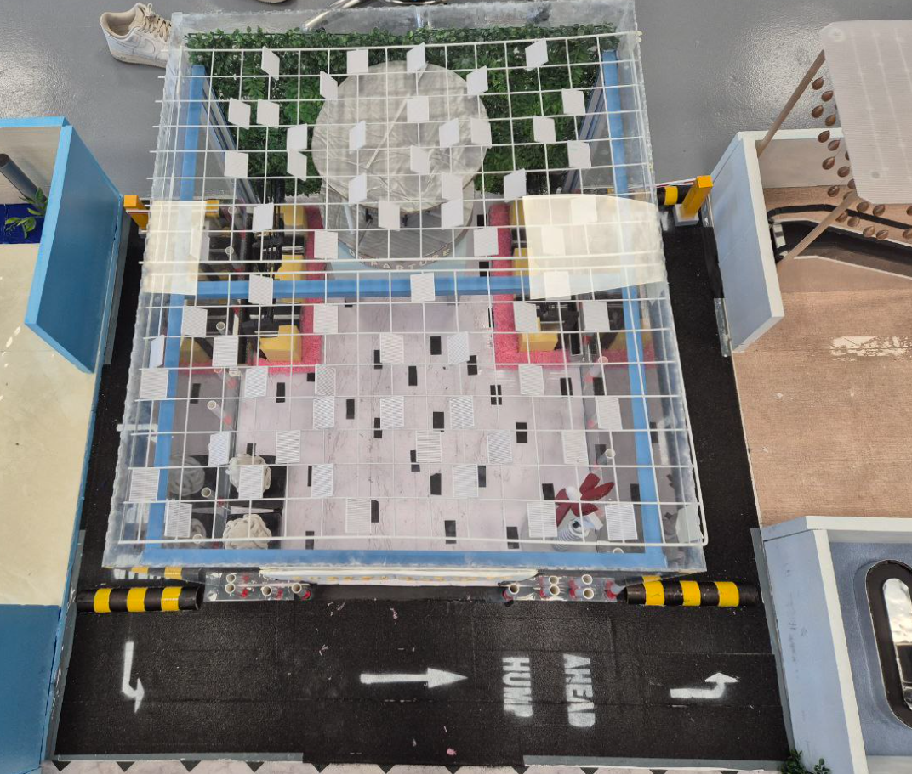  
Top View- Skylight Roof System

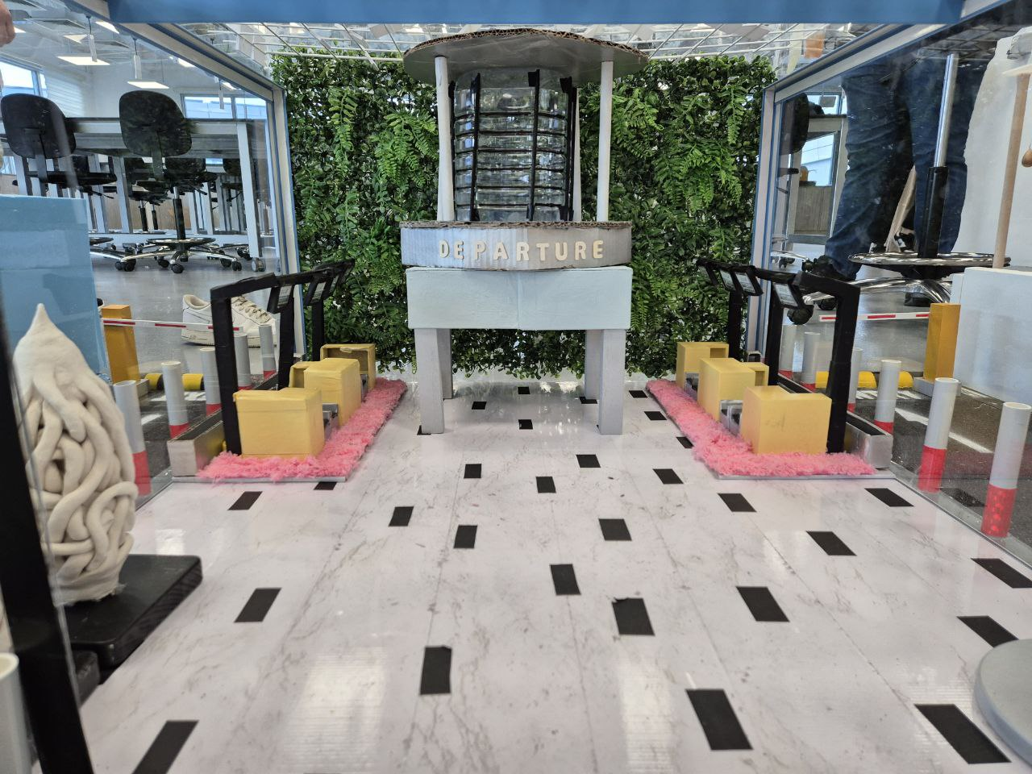  
Interior of Terminal Shell

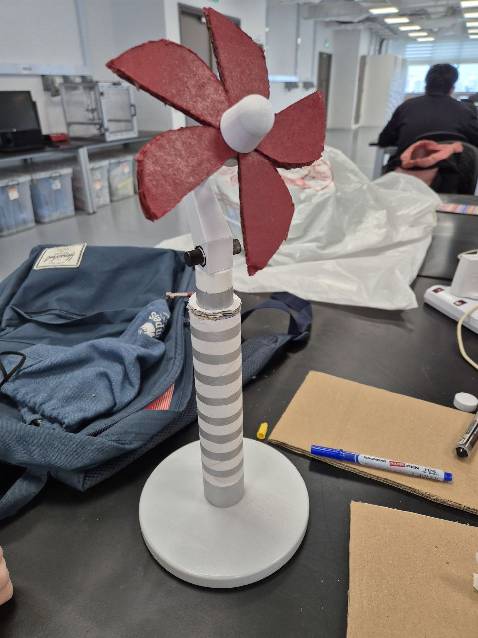  
Daisy

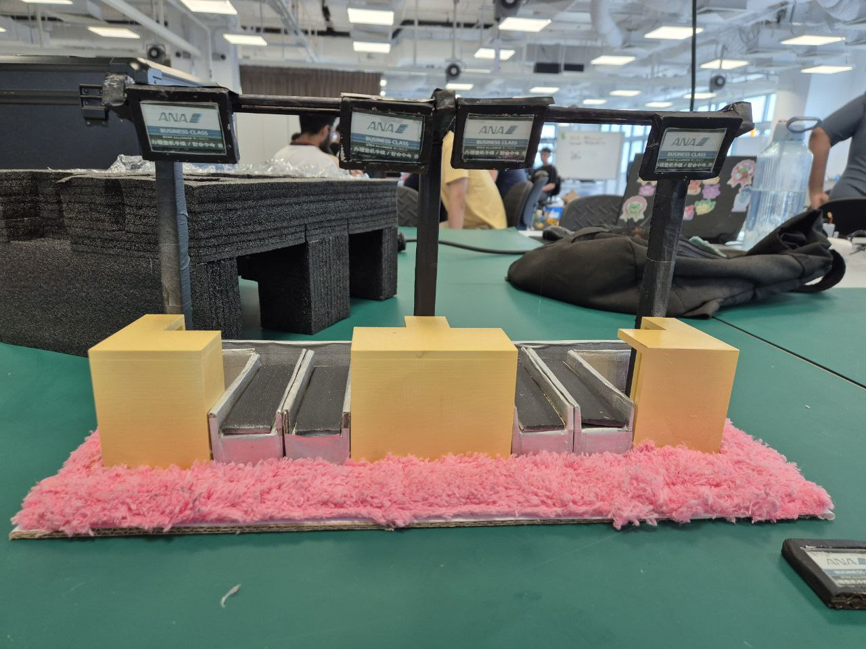  
Airline Counter

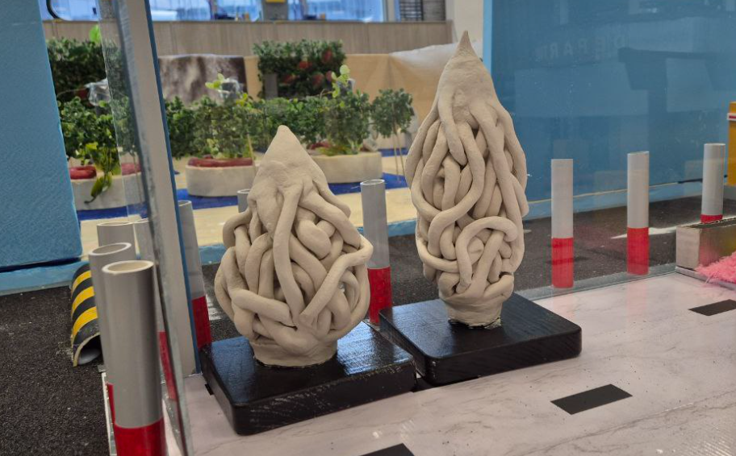  
Floral Inspirations

**RSE2107A - Deploying, Using and Sustaining the System**

#### Introduction

This section describes the activities carried out to deploy, operate, maintain and dispose of the LIMO Bot autonomous navigation system. After completing system realization, the team moved the integrated system into an operational-ready state within the laboratory, executed demonstration runs, and implemented practical measures to ensure reliable performance throughout testing.

#### Deployment

We transitioned the fully integrated system into an operational-ready state within the laboratory demonstration environment.

* Material transport and on-site assembly:

All procured materials, including foam sheets, acrylic panels, PVC barriers, and other arena elements, were brought to the lab. The arena was fully assembled on-site, ensuring it matched the planned layout and adhered to project design specifications.

* Robot setup and system integration:

The LIMO Bot was configured and calibrated within the lab environment, integrating the tracked wheel system and ROS1 navigation stack.

* Operational preparation:

Final ROS configurations, parameter sets, and navigation goals were loaded onto the robot.

#### Use and Operation

Once deployed, the system would be operating to fit its intended environment.

* Operational execution:  
  Initializing the robot, setting navigation goals, and monitoring progress through RViz. The system autonomously navigated multiple plots, avoided obstacles, and activated recovery behaviors when encountering navigation challenges.
* Performance monitoring:  
  Team members actively monitored system health, navigation performance, and interactions within the arena. System logs (rosbags) were recorded for post-run evaluation.
* Emergent properties management:  
  Several system-level behaviors became visible only during full operational runs, including:  
  + LiDAR false reading caused by transparent materials (e.g., acrylic panels).
  + Mitigation: Have distinct physical landmarks near panels (e.g. in Plot 8)
  + Cautious slowdown in narrow passages.
  + Mitigation: Reduced inflation radius and fine-tuned local costmap resolution
  + Recovery loops in complex obstacle sections.
  + Mitigation: Adjust recovery behavior parameters in move_base

Sustainment and Maintenance

Although the project was designed as a short-term demonstration, the team implemented basic sustainment measures to ensure consistent and reliable system performance throughout testing and live runs.

* Hardware checks:

Regularly inspecting the LIMO Bot’s tracked system, battery status, and sensor alignments to ensure proper functioning before and after each run.

* Software adjustments:

Performing minor ROS parameter tuning based on observed behaviors, such as adjusting local planner settings to improve navigation smoothness or obstacle avoidance.

* Arena upkeep:

Inspecting and repairing arena elements when needed, including repositioning barriers, smoothing surfaces, or ensuring visual markers were intact to maintain consistency for the robot’s sensors.

Long-Term Sustainment Considerations

While the project was limited to a temporary demonstration, the team reflected on what sustainment would involve if the system were deployed in a real-world service environment.

* Scheduled preventive maintenance for mechanical components and sensor systems.
* Regular software updates to improve SLAM, localization, and navigation performance as environments change.
* Enhanced monitoring tools for diagnostics and performance tracking.

Disposal

We would be returning all the components to our lab technician Mr. Gary.